Updating AP Direct Deposit Bank Information
Employees can go to P.A.S.S. and update their direct deposit bank information for voucher payments as follows. (If you receive an error message, see Note 1 below.) Updates to AP direct deposit information will not affect payroll direct deposit information or vice versa.
- Log into P.A.S.S.: https://my.uh.edu
- On the menu, select Accounts Payable Information>AP Direct Deposit
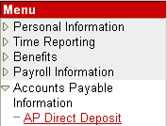
- Update or enter bank information. You must confirm both routing # and account # or you will receive an error message. Complete the “Confirm Routing #” and “Confirm Account #” fields. Click on Save. AP direct deposit information is immediately updated in the Finance System.
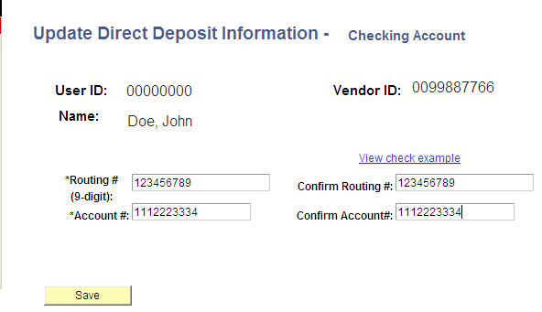
Note 1: If the employee is (1) not setup as a vendor in the Finance System, (2) not classified as an “employee” in the vendor file, (3) on vendor hold with the state, or (4) an inactive vendor, the following message will be displayed:
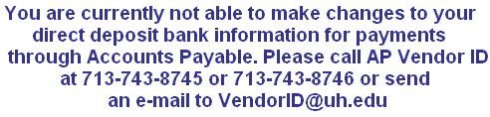
Employees who are not setup as a vendor must fax their UHS Individual Setup Form to Vendor ID at 713-743-0521. The Form is located at: http://www.uh.edu/vendor/ Once the employee is setup as a vendor, he/she can enter AP direct deposit information in P.A.S.S..

E-mail Notification
Employees will receive an automated e-mail notification when they update their AP direct deposit bank information through P.A.S.S.
Example of Email Notification for Update to AP Direct Deposit Information in P.A.S.S.
From: uhsselfservice@uh.edu [mailto:uhsselfservice@uh.edu]

Subject: Accounts Payable Direct Deposit Update

*** This is an automated message. Please do not reply to this e-mail. ***

Your direct deposit bank information for payments through Accounts Payable has been updated. This change will not affect your payroll direct deposit bank information. Please call UHS Vendor ID at 713-743-8746 or 713-743-8745 if you have any questions.

The following bank information was changed in Employee Self Service (P.A.S.S.) for AP direct deposits:
Bank Name
Branch
Routing Number
Account Number

The above changes were made in P.A.S.S. on October 20, 2009 at 09:00 AM and take effect immediately.

If you are not responsible for making the above changes, please contact UHS IT Security via email at security@uh.edu or via phone at 832-842-4695.
++++++++++++++++++++++++++++++++++++++++++++++++++++++++++++++++++++++++++++++++++++++
Notice to Recipient: Unless otherwise specifically indicated, the information contained in this e-mail message is confidential and is only intended for the review and use of the above-named person(s). If the reader of this message is not the intended recipient, you are hereby notified that the recipient is strictly prohibited from any use, storage, dissemination, distribution, or copying of this communication. If you have received this e-mail message in error, please delete this message immediately. Thank you.

